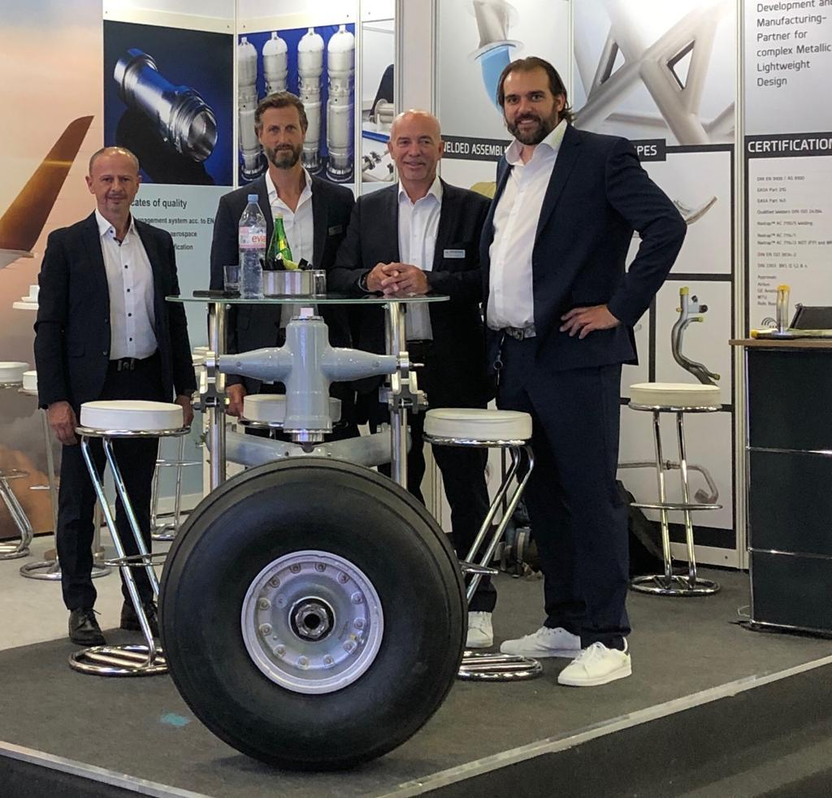

The HEGGEMANN-Team at International Paris Air Show
Le Bourget 17-21 June 2019, Hall2A/D280

